Reshaping Languages in Higher Education Conference 2014

Grand Harbour Hotel, Southampton

9th-10th July 2014

#LLASconf14

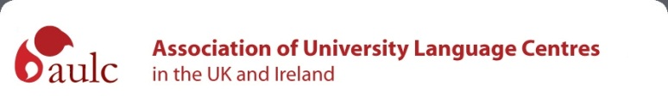
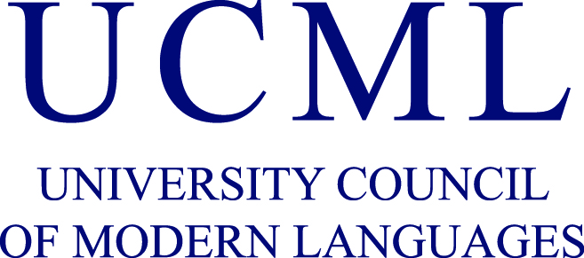

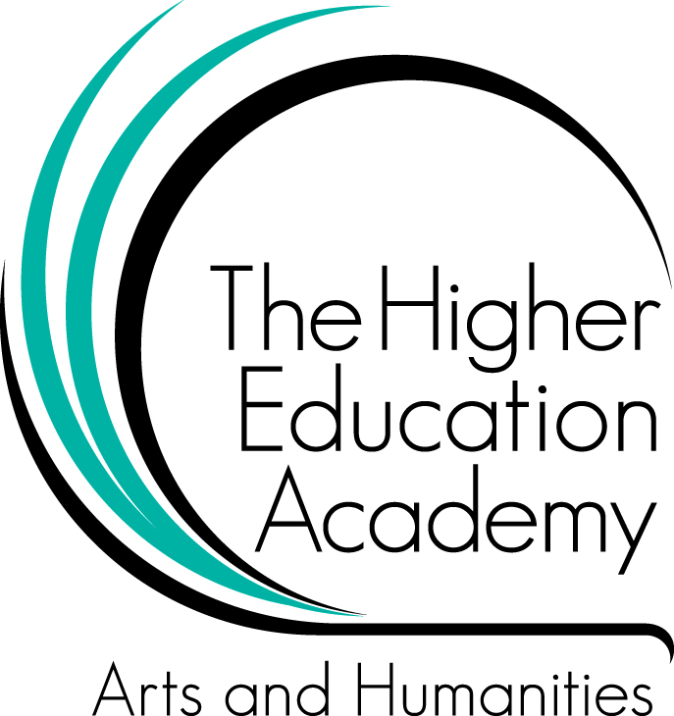

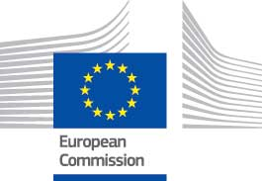

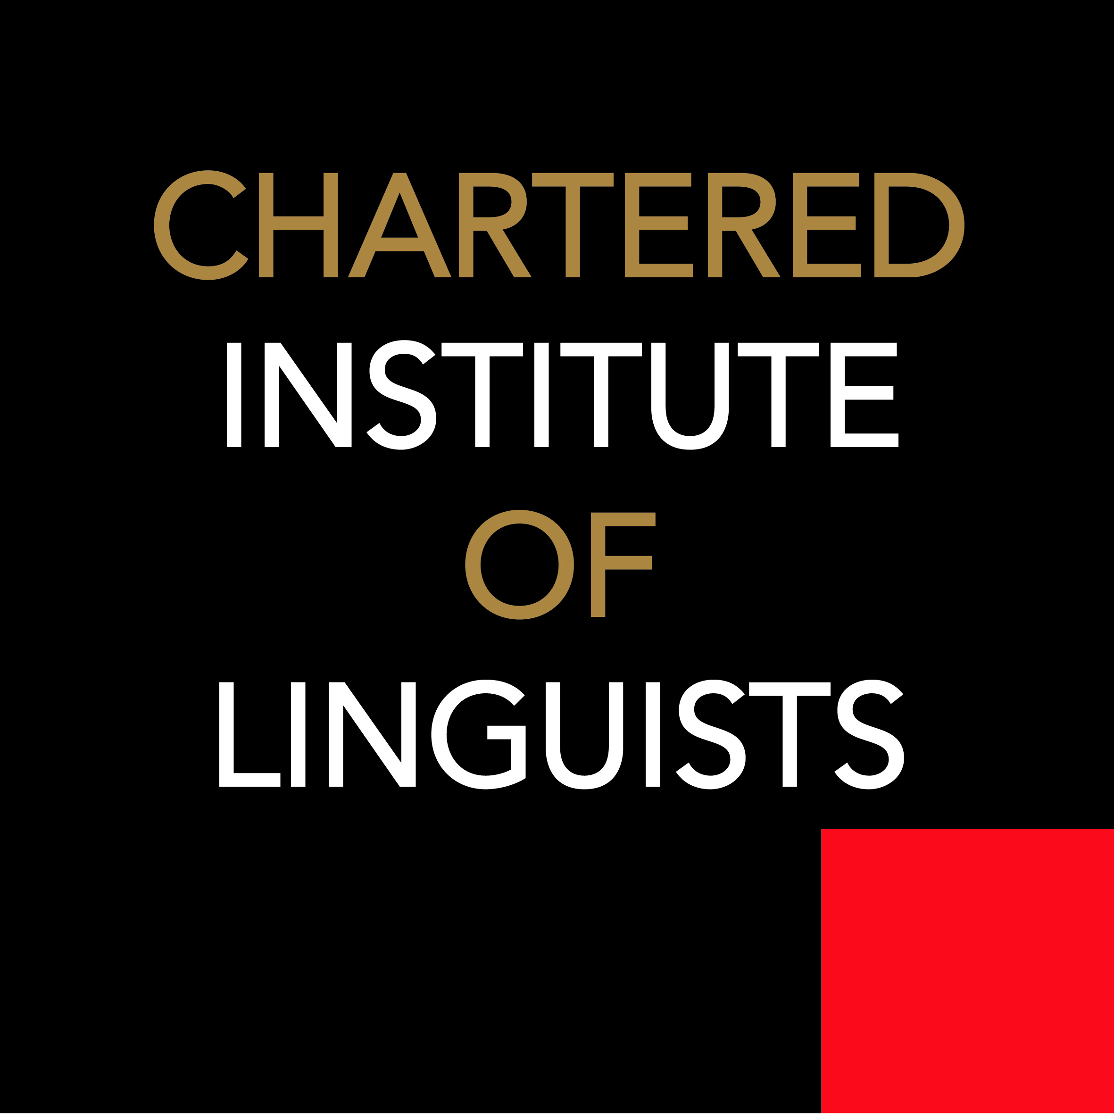
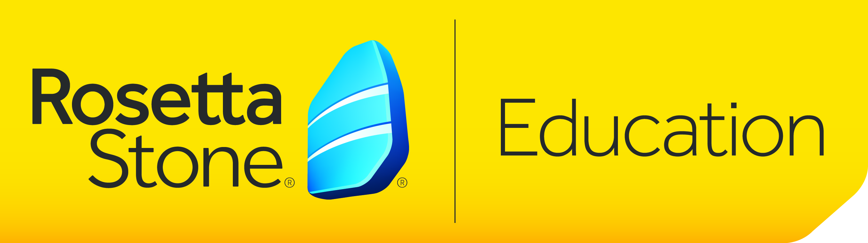
WELCOME

Welcome to Southampton and welcome to the 7th HE languages conference that has been organised by LLAS, UCML and AULC. Paradoxically, languages have never been so high on the political and educational agenda and have never been so vulnerable in secondary and higher education. Events of the last few years have shaken much of the UK’s complacency about our ability to understand what is going on in the wider world and policy makers have begun to take action through a number of initiatives.
The title of the conference, Reshaping Languages in Higher Education, is a reminder that the academic community will have to embrace change if it is to thrive in the future. This is both exciting and potentially painful, but the alternatives are not attractive. This conference is an invitation to take our future in our own hands and to shape it in ways that match our shared values.
The programme provides a rich array of initiatives and ideas that are bringing new momentum to higher education languages. It demonstrates the enduring strength of working together and sharing in our academic community. We are very grateful for the contribution of supporter organisations and sponsors with a commitment to languages. We are confident that this conference will provide an excellent forum for networking, sharing ideas and resources, and for exploring ways to meet the challenges of providing the best education in languages and related subjects for the next generation.
Professor Mike Kelly
Director, LLAS Centre for Languages, Linguistics and Area Studies

I am delighted to welcome you to the 'Reshaping Languages in Higher Education' conference, on behalf of UCML. UCML represents language departments, faculties, schools and centres as well as subject associations in HE nationally and we are acutely aware that the shape of languages in HE has been changing for a while, influenced by a number of factors, including patterns of language learning in other sectors and the introduction of new fee and funding regimes. We have seen increased interdisciplinarity in our taught programmes, the impact of growing institution-wide language programmes and much innovative interdisciplinary research, for example. There has been recent unprecedented exposure through the press and third party publications of the the importance of our disciplines and of the language skills which are their bedrock. And yet, we have also seen a continued decline in many areas across the sector, resulting in impoverishment academically and educationally.
A couple of years ago we produced a toolkit for HE languages called Shaping the Future (available on our website), focussed on 3 strands of 'identity', 'internationalisation' and 'employability'. We hope that these resources have had an influence on some of the reshaping undergone to date. But we need to do more to ensure our disciplines can thrive and this may require increased collaboration across the sector and across disciplines. We have seen how successfully we can work together, through the example of Routes into Languages, and UCML has stimulated many additional collaborative conversations in the sector over the past 18 months. I hope this conference will take these conversations further and provide fertile ground for a future shaped by and owned by us collectively.
Jocelyn Wyburd
Chair, University Council of Modern Languages

On behalf of the AULC, (the Association of University Language Centres in the United Kingdom and Ireland), I am pleased to welcome you to the 'Reshaping Languages in Higher Education' conference. One of the roles of AULC is monitor trends and changes within the sector and to share this information amongst its members and more widely. In recent years, many of AULC’s members have reported a growing interest in and demand for non-specialist language learning – also known as institution-wide language provision. This increased demand is in part a response from students to the realisation that knowing something of other languages is an important attribute for being able to operate successfully in today’s globalised world. Thus we have a broadly positive story to tell, and this makes an important contribution to the discussion on how the language learning and teaching in HE will be ‘reshaped’ in future years.
Dr John Morley
Chair, Association of University Language Centres in the UK and Ireland

PROGRAMME – Wednesday 9th July 2014
9.30 - 10.30 Registration, coffee and exhibition Mayflower Lounge
10.30 – 10.40 Welcome and introductions Mayflower Suite
Professor Michael Kelly, LLAS Centre for Languages, Linguistics and Area Studies
Dr John Morley, Association of University Languages Centres
Jocelyn Wyburd, University Council for Modern Languages

10.40 – 11.10 Plenary: Jocelyn Wyburd, UCML (Chair: Vicky Wright)
How fertile is the ground for us to reshape languages in UK Higher Education?

11.15 – 12.15 Paper session 1

Mayflower 3 | Winslow | Standish
Chair: Alison Dickens | Chair: Lisa Bernasek | Chair: John Morley
Mark Hopkins, Hong Kong University of Science and Technology  Through a glass, darkly: processes and effects of teaching L3 through L2 | Elia Lorena López, University of York  Reflection as a key learning tool in ab initio language delivery | Uwe Baumann and Elodie Vialleton, The Open University  From modules to qualifications – reshaping the languages curriculum at the Open University
Joanne Hooker and John Holder, Southampton Solent University  Dealing with Diversity: Rethinking the Lecture – Seminar Format in language and Content Provision | Kate Borthwick and Irina Nelson, University of Southampton  The XML project: digital literacy and curriculum innovation in ab initio Spanish | Elinor Parks, University of Hull  Investigating the effects of a dualistic degree structure in Modern Languages – Implications for Criticality and Intercultural Competence

12.15-13.00 Plenary: Ian Lyne and Adam Walker Mayflower Suite
Arts and Humanities Research Council (Chair: Jocelyn Wyburd)
The Open World Research Initiative

13.00-14.00 Lunch Restaurant

14.00-14.30 Poster exhibition Mayflower Suite

14.30-15.30 Paper session 2

Mayflower Suite | Winslow
Chair: Zena Hilton | Chair: Vicky Wright
Catherine Chabert, Cardiff University  Reshaping Modern Languages at Cardiff University – a case study | John Morley, University of Manchester  The Growth of the IWLP - how institution wide language programmes can change the landscape of languages

15.30-16.00 Tea and exhibition Mayflower Lounge

16.00-17.00 Paper session 3
Mayflower 3 | Winslow | Standish
Chair: Zena Hilton | Chair: Lisa Bernasek | Chair: Kate Borthwick
Enza Siciliano Verruccio and Pilar Gray-Carlos, University of Reading  Learning to learn languages: the OpAL project | Ruth Hatcher, Laurence Millard and David Tual, University of Cambridge  Looking back to take things forward: reflections on a language portfolio | Helene Pulker, Bill Alder, Elodie Vialleton and Tita Beaven, The Open University  Lessons learnt from online synchronous teaching in a language MOOC
Olga Gomez-Cash, University of Lancaster  Effective transition in language learning – secondary to HE | Charles Burdett, University of Bristol and Naomi Wells, University of Warwick  Transnationalizing modern languages: Mobility, translation and reframing the discipline | Julie Watson, University of Southampton  Exploring international student satisfaction with online courses in acculturation and English language development

17.00-17.45 Plenary: Prof Jenny Jenkins Mayflower Suite
University of Southampton (Chair: Alison Dickens)
The paradox(es) of English in Higher Education

19.00 Conference dinner Mayflower Suite

PROGRAMME - Thursday 10th July 2014
9.00-9.30 Coffee and registration for new delegates
9.30-10.30 Paper session 4
Mayflower 3 | Winslow | Standish
Chair: John Morley | Chair: Zena Hilton | Chair: Erika Corradini
Giuliana Pieri, Royal Holloway, University of London  Languages and Disciplines in the 21st Century: Interdisciplinarity and Italian Studies | Ruth Whittle, Elisenda Marcer, Dorothée Sachse, University of Birmingham  Promoting graduate skills in ML students | Alison Fenner, University of Reading  Language Learning Advisor Scheme: Enabling students to take charge
Cinzia Bacilieri, University of York  Reshaping language teaching in higher education: delivering an interdisciplinary specialist language module to History of Art students | Alessia Plutino, University of Southampton  Bridging the gap : a self-discovering path into intercultural perception of self and the other' | Sonia Cunico and Juan Manuel García-Precedo, University of Exeter  Learning together – learning from and with each other: Towards a community of L2 users through a Peer Assisted Learning Scheme at Exeter

10.30-11.15 Plenary: Translating and Interpreting Panel Mayflower Suite
(Chair: Erika Corradini)
Helen Campbell, Director of National Network for Interpreting
Christina Schaeffner, from the National Network for Translation
Angeliki Petrits from European Commission Representation UK

11.15-11.45 Coffee and exhibition Mayflower Lounge
11.45 -12.45 Paper session 5
Mayflower 3 | Winslow | Standish
Chair: Angela Gallagher-Brett | Chair: Vicky Wright | Chair: Alison Dickens
Cathy Hampton, University of Warwick  Out of the frying pan and into the classroom: student producers transform their year abroad encounters into learning objects for schools | Ann Carlisle, Chartered Institute of Linguists  Routes to Language Qualification – combining the academic with the professional | Cecilia Goria and Marion Sadoux, University of Nottingham  Eclectic approach or multimodal experience: a professional development programme for language teachers
Sarah Schechter, Anglia Ruskin University  Collaboration - more than the sum of its parts..? | Billy Brick, Tiziana Cervi-Wilson, Coventry University  Add+vantage Coventry University: Delivering institution wide languages provision with an employability framework | Alison Nader and Alison Nicholson, University of Reading  Adding linguistic competence to the graduate profile: moving the non-linguist (CEF A2) from parrot to communicator
12.45-13.30 Plenary: Chris Millward, HEFCE Mayflower Suite
(Chair: Mike Kelly)

13.30-14.30 Lunch and exhibition Restaurant / Mayflower Lounge
14.30-15.30 Paper session 6
Mayflower 3 | Winslow | Standish
Chair: Jocelyn Wyburd | Chair: Kate Borthwick | Chair: Angela Gallagher-Brett
Patricia Romero de Mills, University of Southampton  Promoting intercultural learning among Anglophone students during residence abroad | Teresa Mackinnon and Katsuko Nagata, University of Warwick  Teaching languages through a supportive learning environment to enhance global graduate skills | Susana Pinto, University of Aveiro  Plurilingualism in higher education: Portuguese students’ voices
Sandra Salin and Damien Hall, Newcastle University  Better French Living through Independent Learning | Benoît Guilbaud, University of Manchester  Bring your own vocabulary: Engaging students in vocabulary learning with mobile and collaborative technologies | John Holder and Joanne Hooker, Southampton Solent University  Developing intercultural and linguistic awareness on international modules

15.30-15.45 Tea Mayflower Lounge
15.45-16.00 Closing plenary Mayflower Suite

Please note: Photographs will be taken during the event and may be used by the conference organisers for website and printed materials. If you do not want to appear in a photograph, please let the registration desk know.

